MYSQL QUERIES:

select * from complaints;
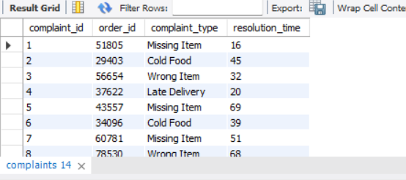
select * from customers;
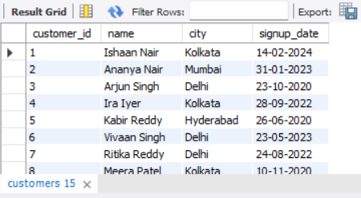
select * from delivery_partners;
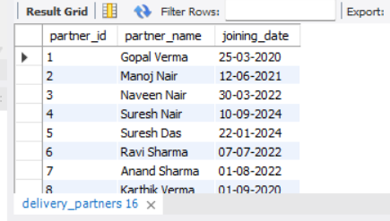
select * from forders;
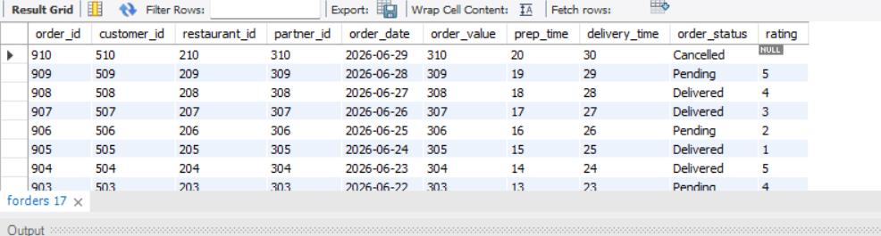
select * from restaurants;
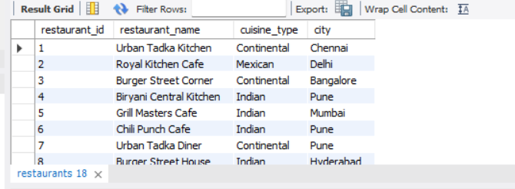

GIVEN QUESTIONS:

1-- RELEVANT EDA QUERIES
SELECT COUNT(*) AS total_orders
FROM forders;
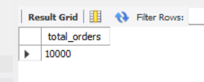

2-- Delivered vs Cancelled Orders
SELECT order_status, COUNT(*) AS orders
FROM forders
GROUP BY order_status;
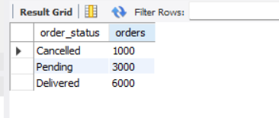

3-- Average Delivery Time
SELECT AVG(delivery_time) AS avg_delivery_time
FROM forders
WHERE order_status = 'Delivered';
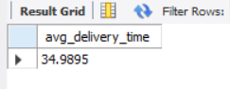

4-- Average Rating
SELECT AVG(rating) AS avg_rating
FROM forders
WHERE rating IS NOT NULL;
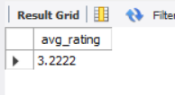

5-- TOTAL ORDERS PER CITY
SELECT
c.city,
COUNT(f.order_id) AS total_orders
FROM forders f
JOIN customers c
ON f.customer_id = c.customer_id
GROUP BY c.city
ORDER BY total_orders DESC;
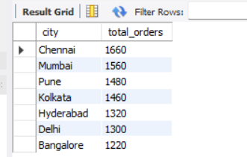

6-- PEAK ORDER HOURS
SELECT
HOUR(order_date) AS order_hour,
COUNT(order_id) AS total_orders
FROM forders
GROUP BY order_hour
ORDER BY total_orders DESC;
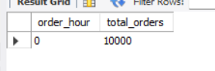

7-- REVENUE PER RESTAURANT
SELECT
r.restaurant_name,
SUM(f.order_value) AS total_revenue
FROM forders f
JOIN restaurants r
ON f.restaurant_id = r.restaurant_id
WHERE f.order_status = 'Delivered'
GROUP BY r.restaurant_name
ORDER BY total_revenue DESC;
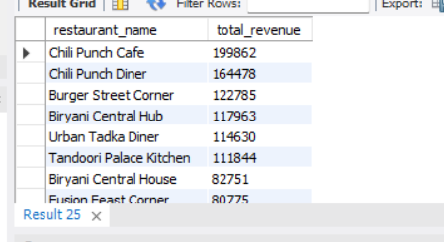

OVERVIEW:

In this project, SQL was used to understand and analyze food delivery data stored across multiple tables such as orders, customers, restaurants, delivery partners, and complaints. The queries were written to explore the data, perform basic EDA, and answer important business questions.

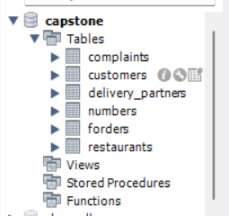
Overall Summary :
- SQL helped analyze large food delivery data efficiently
- EDA queries gave a clear picture of orders, delivery performance, and ratings
- City-wise and time-based analysis helped identify demand patterns
- Revenue analysis highlighted top restaurants
- These insights support better business and operational decisions

